CiteLens - Instructions[1]

# Description of tool:

CiteLens is a visualization tool for context and content analysis of citations. The prototype we are building consists of two distinct views, “compare” and “contextualize”, with a secondary view for displaying the internal structure of complex footnotes. As of right now, only the first view prototype is completed, while the “contextualize” view it’s in its last stages of design.

Some elements of the interface are present in all views:

* Title of book analysed
* Bibliography panel
* Reading panel
* Full text visualization

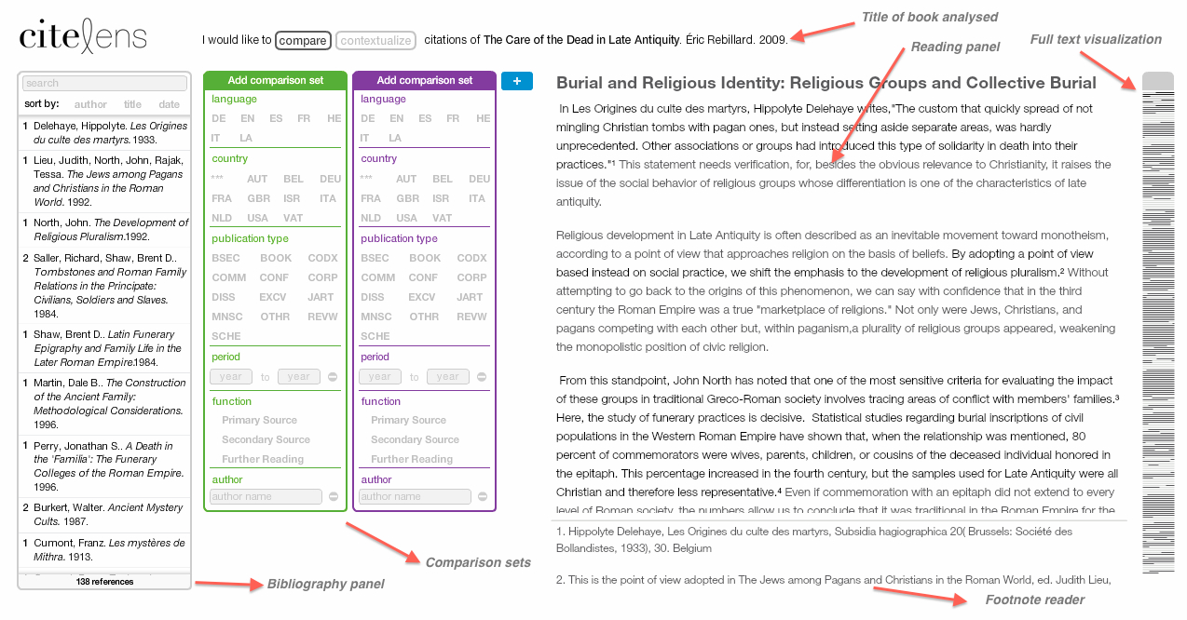

# Compare View

## 1. Bibliography Panel

### Description:

The bibliographic panel lists the bibliographic sources in the document, displaying the author, title and year of publication for each reference. The number in the top-left corner indicates the number of times the title was cited in text. Default sorting is by location of the first reference in text; the list is scrollable. A counter is located at the bottom of the list, giving the total number of works listed. As users interact with the tool and create their comparison sets, the bibliography panel is filtered to display only the titles that meet the filtering criteria and the counter at the bottom of the list is modified accordingly.

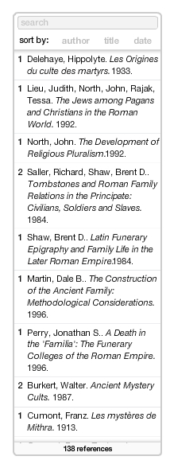

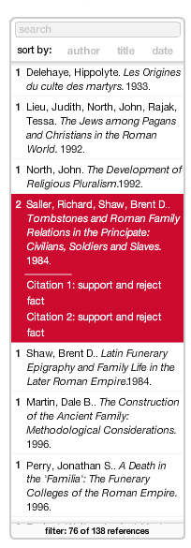

#### Actions:

* Sort:
  + By author (alphabetically)
  + By title (alphabetically)
  + By date of publication (chronologically)
  + To undo sorting, just deselect the sorting criterion by clicking on its label again.
* Search:
  + Author
  + Title

Search is dynamic, autocomplete enabled. The autocomplete panel shows the first 6 (max) occurrences. Choose one either by clicking on the item, navigating by arrows, or hitting “return” to search for the string in the textbox. The engine will hide the references that do not match the search criterion and reorganize the other to the top of the list. To clear the search, click on the “x” button in the search box.

* Reference selection:

The user has the option to select a single title in the bibliographic list by clicking on it. Selected title will then be displayed in white text on red background, with the individual citation occurrences listed below with the functions of said citations specified when identified by the XML. When the reference selection is active, the text portions to which the reference is connected are displayed in red ink inside the reader panel, as are the footnotes in which the reference is mentioned. Furthermore, the full text visualization to the far right of the screen will also highlight the location in text of the individual instances of citation for the selected reference.

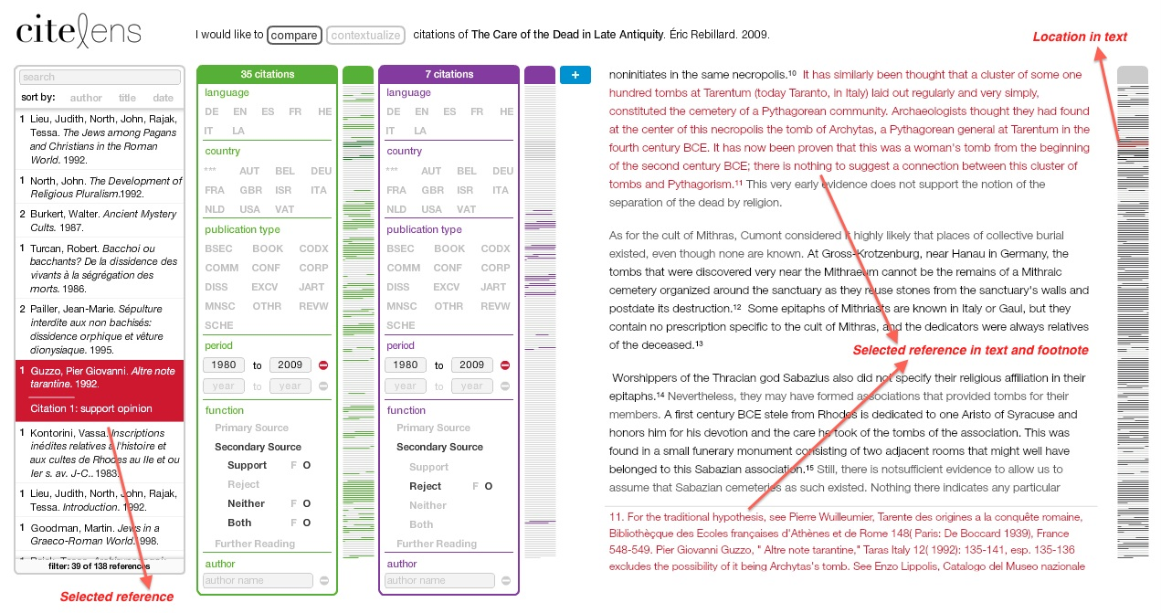

# 2. Comparison panel

## Description:

The comparison area displays in the beginning the filtering panels to be used in the creation of comparison sets. Initially, only two panels are displayed, with the option to add a third if desired. If three comparison sets are active, the user has the option to turn of anyone of them by clicking on the “x” at its top right corner, thus returning to a two-term comparison. Once a comparison set is created by selecting at lest one criterion in the filtering panel, a visualization showing the length and position of the text chunks connected to the references that match the filtering criteria is displayed to the right of the filtering panel.

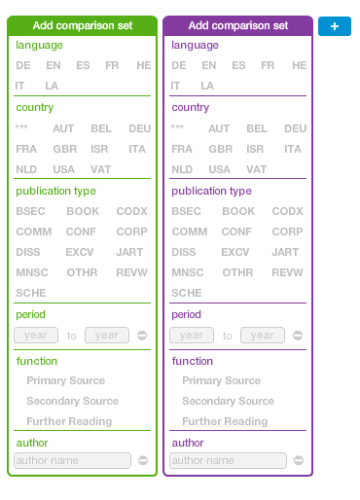

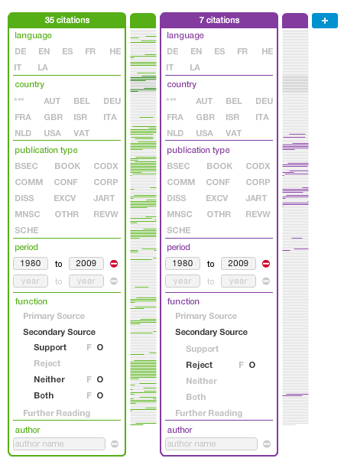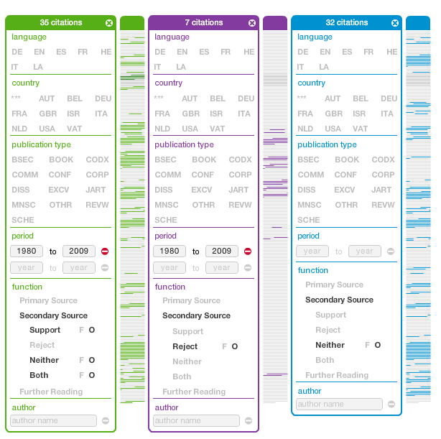

### Filtering panels:

#### Filtering criteria:

* Language:
  + Lists all the languages of the references cited in text.
* Countries:
  + Lists all the countries of publication for the references cited in text.
* Publication type:
  + Lists all publications types, including types that are not found in the document.
* Period:
  + Set the period limits. If one of the limits is left empty, the engine assumes the earlier reference for start date or the year of publication of the work being analyzed for end date. Add more than one period or remove a previous period set.
* Function:
  + Lists all citations functions, including those not present in the document. The function classification we adopted is based on the classification developed by Caroline Frost[2]; it distinguishes between primary and secondary sources, facts and opinions cited, and marks the quality of the relationship between the citing and cited texts.
* Author:
  + Set a particular author. As in the search box of the bibliography panel, autocomplete is available. Add more than one author or remove a previous selection.

#### Filtering logic:

* language AND country AND publication type AND period AND function AND author
* function = (primary OR secondary) AND further reading[3]

The color themes of the comparison sets are a passive design feature with no particular significance.

When one ore more comparison sets are active, the bibliography panel will display only the titles that are included in at least one of the comparison sets created.

E.g.: Set 1 shows 45 books. Set 2 shows 34 francophone references. The reference list will show 59 items, which is the combination of the two sets. The sum does not match (45 + 34 > 59) because there are some books that are in French, so the engine will only count them once.

### Actions:

* Select the filtering criteria for the comparison sets by clicking on the criteria labels or filling in the fields.
* Mouse over the labels in the language, country or publication type categories to be shown the full names of the criteria.
* Clear the filter set by clicking on the “x’ button on the top-right of the panel.

### Future implementation:

* Allow the user to rearrange the visualization panels in order to have a better visual comparison.
* Allow the user to employ the visualization panels as navigation tools (the user shall be able to click on a citation displayed in a comparison set and to have the reader “jump” to that location in text)

## 3. Reader

#### Description:

The reading panel is split in two distinct areas, one for the main text, and the other for the footnotes. Both areas can be scrolled independently and, by clicking on a note index in the main text, the footnote area will automatically scroll to that footnote. The reading panel is connected to both the bibliographic list and to the full text visualization. As the user scrolls through the main text, the current location is highlighted in the full text visualization. Conversely, if a reference in the bibliography panel is selected, the fragments of text to which said reference is connected, as well as the footnotes in which the reference is made, will be displayed with red ink in the reader.

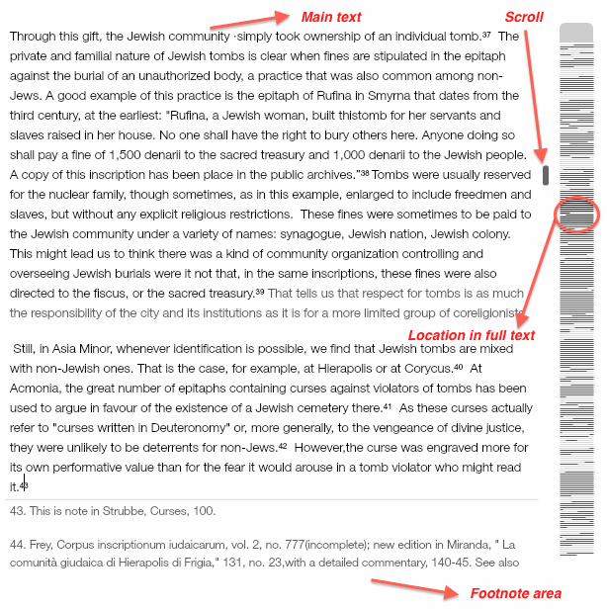

#### Actions:

* Scroll through both the main text section and the footnote section
* Click on a note index to scroll the footnote section to the corresponding note.

#### Future implementation:

* Make scrolling the two areas congruent
* Other implementations in the contextualize view

## 4. Full text visualization

### Description:

The full text visualization is meant to be a navigation aid, a representation of the full text with the areas supported by citations mapped in black and the areas of original contributions to the text highlighted in light gray. When a reference is selected in the bibliographic panel, the areas of text to which said reference is connected are highlighted in red in the full text visualization. Also, current location in text in the reader is marked on the full text visualization)

#### Future implementation:

* Create space breaks between text segments (chapters, parts, sections, etc.)
* Turn it into a navigable map of the text (i.e., make all locations clickable and connected to the reader panel)

##### Notes:

* No interaction is ready yet.

# Contextualize View (in final design stage, not built yet):

## Description:

Since footnotes are still very common in humanist monographs, especially in traditional disciplines, they have a substantial place in understanding the role of references and their relationship with the citing text.

The reason why footnotes are particularly important when trying to understand citation in the humanities is tied into their potential for complexity. Some footnotes, like the one shown here, contain both multiple references and fragments of text related to said references and meant to place them in context.

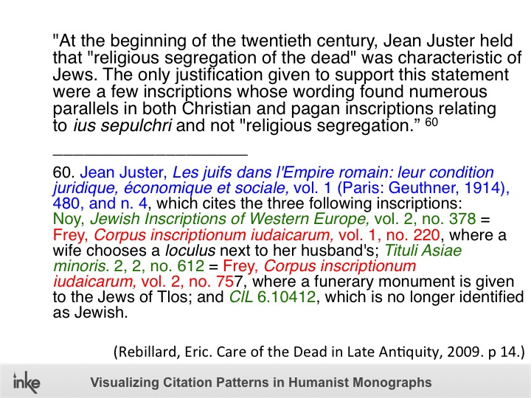

We considered the context in which a citation occurs, the span of text to which it is closely connected to be interest, so we decided to visually represent the connections between text and citations and also the relations, where stated, between different references cited inside the same note.

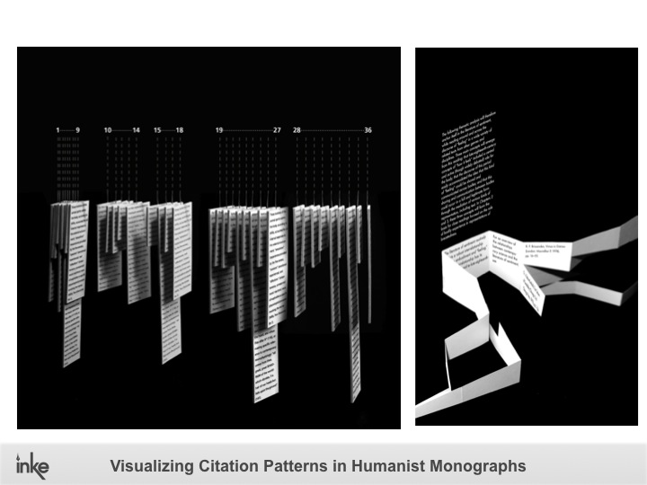

We translated these initial metaphorical representations of note contexts and structures into the second view of CiteLens.

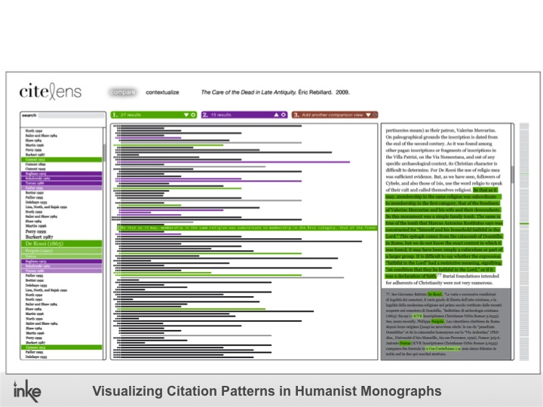

Here, the sets of citations delineated in the “compare” view are maintained; while the list of references is replaced by a list of individual instances of citation, displayed sequentially. The scene in the middle is taken over by the representations of the spans of text as they are supported (or not) by individual citations. The dots to the left of the text segments represent the number of individual references attached to the same segment of text (i.e. included in the same footnote).

When more than one dot is attached to the same string of text, we are usually faced with a complex footnote. To access a visual representation of it, the user needs to click on the gray box containing the footnote in the reader.

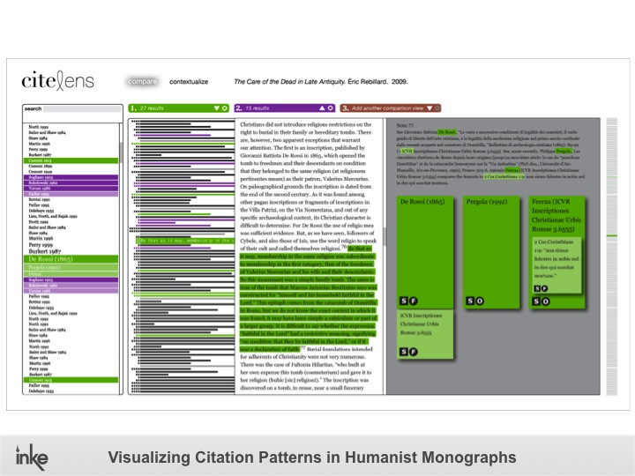

As you can see from this example, both the relationship with the citing text and the relationships inside the footnote are marked – the former by labels and the later by nesting. We learned from encoding our samples that references co-cited inside the same note can be in three types of explicitly stated relationships: “citing”, “cited by”, and “alternative”. We have in this particular case an enumeration of three citations; one of them is given an alternative while another is mentioned together with one of its references.

1. Only one of the two views is ready. “Contextualize” view is in the final design stage and will likely be implemented later this year.
2. Frost, Carolyn O. “The Use of Citations in Literary Research: A Preliminary Classification of Citation Functions.” *The Library Quarterly* 49, no. 4 (October 1979): 399–414.
3. “further reading” is, according to the function classification employed, just a label attached to either a primary or secondary source, when the reference is mentioned by the citing author as an additional source of information on a subject.